2010年山东省潍坊市初中学业水平考试
英语试卷
1．本试题分第Ⅰ卷和第Ⅱ卷两部分。第Ⅰ卷75分，第Ⅱ卷45分，共120分，考试时间为120分钟：
2．请在答卷前先把自己的姓名、准考证号、考试科目和试卷类型涂写在答题卡上。考试结束时，试题和答题卡一并交回；
3．请将第Ⅰ卷选择题答案标号用2B铅笔涂在答题卡上，一定要看清题号并且涂得清楚。
第Ⅰ卷（共75分）
一、听力测试（共20小题；每小题1分，满分20分）
（一）听句子，选择适当答语，每个句子读两遍。
1．A．I'm line． B．It's fine． C．He's fine．
2．A．Kind． B．De1icious． C．Funny．
3．A．Yes，I do． B．No, thanks． C．Sorry, I'm new here．
4．A．This is Betty speaking．
B．Hold on，please．
C．She is at home．
5．A．Yes，they are．
B．Take it away, please．
C．I'm sorry to hear that．
（二）听对话和问题，选择符合每个问题答案的图面，每段对话和问题读两遍。
6．
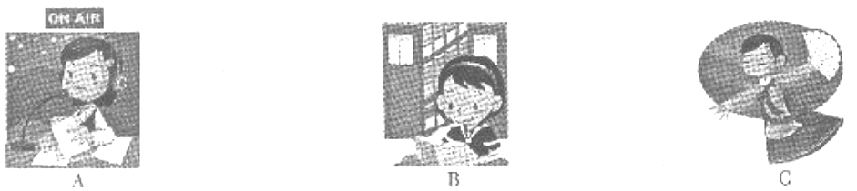
7．
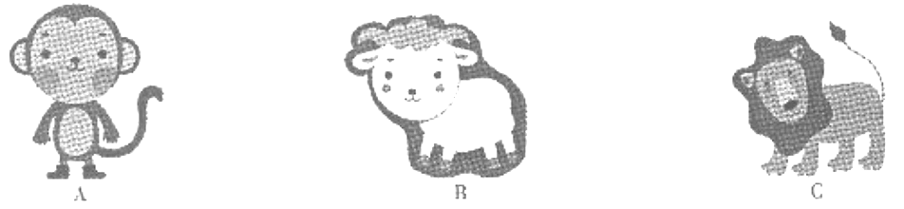
8．
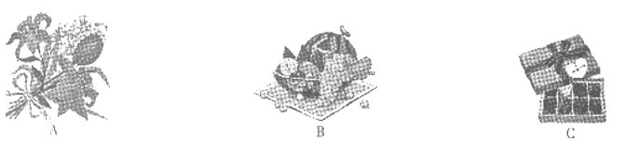
9．
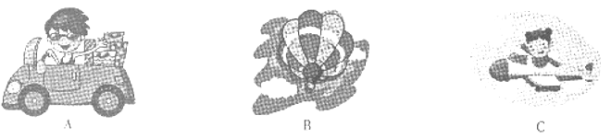
10．
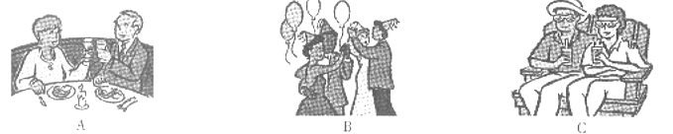
（三）听对话，根据对话内容选择每个问题的最佳答案，对话和问题读两遍。
听第一段对话，回答第11、12题。
11．In fact, what time did the man show his ticket?
A．At 2：25． B．At 2：30． C．At 2：35．
12．Why was the man late for the train?
A．Because the train left earlier．
B．Because he didn't know the time．
C．Because there was something wrong with the clock．
听第二段对话，回答第13、14、15题。
13．What’s wrong with Ann?
A．She has a cold． B．She can't breathe． C．Her chest hurts．
14．What's the problem?
A．A factory produces harmful gases．
B．The air on the earth is polluted．
C．She wants to leave the village．
15．What are they going to do?
A．Go to see a doctor．
B．Look for a better place．
C．Write a letter to a newspaper．
（四）请听一段新闻，根据新闻内容，完成下列简要概述，每空一词，新闻读两遍。
注意：听力测试结束后，请将本题答案填写在第Ⅱ卷相应的位置上。
News Information Card
News 1 | On July 12, in Spain, a 1 appeared in a park. At last the 2 returned it to the zoo．In the accident, 3 was hurt．
News 2 | British people sent 4 billion text messages last month．That means more than 5 million each day．
二、单项选择（共15小题；每小题1分，满分15分）
从下列各题所给的A、B、C、D四个选项中，选出可以填入空白处的最佳选项。
16．Auatar（阿凡达）is such _________ wonderful science fiction movie that I want to see it _________ second time．
A．a, a B．a, the C．／, the D．／, a
17．Michael Jordan has failed over and over again in his life．And that's _________ he succeeds．
A．what B．when C．why D．where
18．I'm expecting a pet dog for long，but mom has no time to buy _________ for me．
A．it B．one C．this D．that
19．At least 300 million people are using QQ _________ by Ma Huateng to chat on line．
A．create B．creates C．creating D．created
20．The cookies _________ good．Could I have some more?
A．taste B．smell C．feel D．sound
21．—Tom, I'm watching a football match．What about you?
—_________
A．So do I． B．So am I． C．So I do. D．So I am.
22．—Sorry, sir. I made a mistake again．
—_________ Practice more and you will do better．
A．Never mind． B．I'm not sure，
C．You're welcome． D．Don't mention it．
23．—Is Jessica giving us a speech this evening?
—No, it _________ be her．She _________ to Japan．
A．mustn't；has gone B．mustn't; has been
C．can't; has gone D．can't; has been
24．A moment, please．I'm checking if Mr. Smith _________ free tomorrow．
A．is B．being C．to be D．will be
25．China is developing _________ of all the countries in the world．
A．fast B．faster C．fastest D．the most fast
26．Alice in Wonderland is a fantastic movie. It's about _________．
A．how did Alice cad the Red Queen's reign of terror（恐怖统治）
B．what did Alice end the Red Queen's reign of terror
C．how Alice ended the Red Queen's reign of terror
D．what Alice ended the Red Queen's reign of terror
27．—Would you like tea or coffee?
—_________ is OK．I really don't mind．
A．None B．Either C．Neither D．Both
28．The little elephant is afraid to go alone．He always walks _________ his mother．
A．besides B．beside C．below D．under
29．You have to leave now _________ you can catch the early bus．
A．so that B．as soon as C．because D．if
30．—_________ do you have PE lessons?
—There times a week．
A．How long B．How soon C．How many D．How often
三、完形填空（共10小题；每小题1分，满分10分）
阅读下面短文，掌握其大意，然后从A、B、C、D四个选项中选出最佳选项。
A 14-year-old boy from the USA was described as a hero yesterday after he saved the life of a woman in another country．
Dean Bluey from Dallas，Texas，was a school boy who has much 31 in computer．One day，he 32 an email to a friend on the Internet．Suddenly he received a message saying “Help! Pain! Help!”．"The message was from Finland， 33 kilometers away from America．
“I didn't know 34 I should do，”Dean said to a reporter afterwards．“It was really difficult to tell if the message was real．”So Dean did nothing at first． 35 the message kept coming．
“By then it was easy to see that someone was in trouble,” Dean explained. He 36 and discovered that the sender was a student called Tarja, who was alone in a university library. She was ill. What was 37 , there was no phone around her. Her only way of communicating with the world was by email. Dean got in touch 38 the police immediately. And they realized that the situation was quite serious. They called the police in Finland. Then an ambulance rushed to the library. 39 , she was still alive and was sent to the hospital quickly.
“I'm glad she's OK,” Dean said. “It's hard to believe, but 40 saved her life.”
31．A．interest B．interested C．interesting D．interests
32．A．sent B．sends C．was sending D．is sending
33．A．thousand B．thousand of C．thousands D．thousands of
34．A．how B．what C．where D．when
35．A．So B．And C．But D．As
36．A．telephoned B．replied C．found D．talked
37．A．better B．worse C．harder D．easier
38．A．with B．on C．to D．at
39．A．Hardly B．Happily C．Luckily D．Carefully
40．A．a boy B．doctors C．the police D．email
四、阅读理解（共15小题；每小题2分，满分30分）
阅读下列短文，从每题所给的A、B、C、D四个选项中选出最佳选项。
A
When you are in trouble，whom will you tell the problems to and ask for help? Someone has made a survey in a middle school．500 students were asked to choose one answer among friends or classmates，parents，head teacher and teachers．Here is the result．Please read the chart and try to get some information．
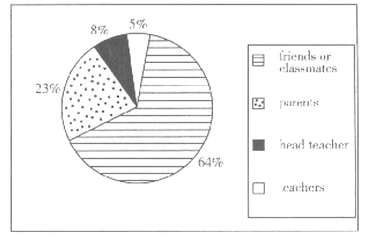
41．Most of the students would like to talk about their problems with _________．
A．friends or classmates
B．parents
C．head teacher
D．teachers
42．Less than a quarter of the students chose parents, the most possible reason is __________．
A．parents don't love their children
B．children don't trust their parents
C．parents aren't able to give good advice
D．sometimes parents and children can't understand each other
43．According to the fact that only 13％of the students wanted to communicate with their head teacher or teachers，what is the best suggestion?
A．The students should work harder．
B．The students should listen to the teachers more carefully．
C．The teachers should be more strict with the students．
D．The teachers should pay more attention to the students' feelings．
B

When we talk about stars, especially women stars，it seems that they are always young，pretty and own charming body shapes．But recently a Britain's Got Talent（英国达人）star Susan Boyle has changed our views absolutely．
Simon Cowell，one of the judges of the talent show spoke of his shock over Ms Boyb's voice．”This lady came up，and I'm thinking, ‘This will take five seconds and I can go to have a cup of tea.’ That changed when she began to sing I Dreamed a Dream from Les Miserables. She knew we were going to have that reaction and just to see that look of satisfaction on her face midway through —it was one of my favorite moments,” Cowell said.
The performance was posted On line and before long，the 47-year-old Scottish woman has been famous all over the world．
Speaking from her home in Scotland．Ms. Boyle said that she hadn't thought of changing her appearance．She said that her friend helped her with make-up．“I mean，that's hardly a makeover．”she added．
Ms. Boyle also spoke of the reason she first began to explore her vocal talents．”I was kind of slow at school, so getting something like singing was a good way of hiding behind that and thus it built my confidence．’’
44．Susan Boyle is __________．
A．a judge B．a reporter
C．a beautiful lady D．a Scottish woman
45．Susan Boyle had a look of satisfaction on her face when she was singing because _________.
A．she was confident of her singing
B．she was satisfied with the judges
C．she was pretty and in good shape
D．she sang the song，I Dreamed a Dream from Lea Miserables
46．According to the passage，which is NOT true?
A．It was the vocal talents that built Susan's confidence．
B．Susan Boyle was not good at her lessons when at school．
C．Susan Boyle became famous because of her appearance．
D．Simon Cowell didn't think Susan Boyle a good singer at the time sight．
47．What can we learn from Susan Boyle's success?
A．It's never too old to learn．
B．It's easier to succeed at the age of 47．
C．If you have a dream，try to make it come true!
D．If you are not able to study well，to be a singer instead．
C
Expo 2010 is held in Shanghai from May 1 to October 31．People all over the world are looking forward to it．Here are several golden rules on how to best plan your hip．
Rule 1：Do your homework
Read everything you call before going．Really study the maps．Know the pavilions．Arrive at the entrance nearest Io the things you want to see．Have a plan．It will make a big difference．
Rule 2：Allow plenty of time
Expo 2010 is the largest attraction event in the history of the world．It will take many days to see it．Plan to spend from five to eight days or more seeing it．
Rule 3：Pace yourself
Expo is enormous．The distances are punishing．It is better to spend a day seeing a single area than to man hack and forth all over the site．Remember to wear the most comfortable shoes．Never mind what they look like．
Rule 4：Get going in May
At many Expos the crowds are smaller in May and in early June than any other time．And beware the last two weeks．During every Expo, people delay their visits and then in early October they suddenly realize．“Expo will close soon! I haven’t seen it!’’As a result, the last several weeks usually have the most crowded days of the entire Expo．
Rule 5：Find out what everyone else is doing-and do the opposite
If you don't like large crowds and long lines．do the opposite．Here is all example：Most people go on Saturdays or on holidays, So avoid Saturdays and holidays．Go on weekdays when most people are at work．
Rule 6：Turn up
Expo 2010 is the largest celebration in China's history-an amazing once-in-a-lifetime event．When it is gone and it will never be seen again．So whatever you do，don't miss it!
48．Expo 2010 will last _________．
A．five to eight days
B．several weeks
C．six months
D．a year
49．According to Rule 4，you'd bettor not go to Expo on ________．
A．May 3 B．July 5 C．September 16 D．October 20
50．When there are lots of people waiting in line to see the most popular activations, what’s your best choice?
A．I'll wait in line as other people do．
B．I'll go back and return tomorrow．
C．I'll visit the less crowded places instead．
D．I'll sit on a bench to have a rest for about two or three hours．
51．In Rule 6 “turn up” here means ________．
A．don't miss it B．come and see
C．mnke the sound louder D．never be seen again
D
When I was a foreign teacher in China，every day I taught English to my students and they taught me about China．One day the topic mined to saying “I love you”．I was shocked to learn that not one of my students had said this to their mothers，nor had their mothers said it to them．“Does your mom love you?” “Of course，”they answered．
“How do you know?” was my logical question．They responded that their moms cooked and Always told them what they were doing wrong to show their earning．I was strummed. So mom's cooking and criticizing read our as “I love you”．”Then how do you say ‘I love you to her?” They agreed that getting good grades, followed by good jobs would be how they showed their love.
I come from a culture where most people are expressive enough，so I repeated these queries in clauses over time．Gradually，I began to get different responses．Some of them had exchanged those sentiments with their moms．
One of my favorite stories of change came from a girl．When she came home from university，her mother met her at the door and hugged（拥抱）her．This had never happened before，but her mom said，“Now that you have gone I have more time to myself．I noticed that in some places mothers and children hug each other and I decided it was a good idea and that I would begin hugging you．”
In my family we all say “I love you” a lot．While it is true that we often say the words without having great depth of feelings at that moment，it is almost like a blessing we give each other. Those three little words carry a world of meaning，even when said as a greeting, but most especially if they are the lax words we say to or hear from those we love．
52．The foreign teacher _________．
A．comes from America B．is a young woman
C．is expressive enough D．knows much about China
53．Chinese people prefer to show love by __________．
A．saying “I love you” B．cooking
C．getting good grades D．doing something helpful
54．In paragraph 4, what's the real meaning of the mom's hugging?
A．She is meeting her daughter at the dour．
B．She loves her daughter and misses her．
C．She is glad that she has more time to herself．
D．She finds it interesting to hug her daughter．
55．What's the main idea of the passage?
A．Say “I love you” more to your family．
B．Say “I love you” a lot to Chinese people．
C．Say “I love you” as a greeting to others．
D．Say “I love you” without great depth of feelings．
第Ⅱ卷（共45分）
五、词汇考查（共7小题；每小题1分，满分7分）
根据句意和首字母提示完成单词，使用了语法正确．意义通顺。请将答案写在题后相应的横线上。
1．November is the e_______ month of a year．
2．Lakers will play a_______ Rockets in the NBA match tonight．
3．Lingling, Betty and I enjoyed o_______ at the party last night.
4．Dragon Boat Festival is one of the Chinese t_______ festivals．
5．F_______, the soldiers arrived at the village after a few days’ long walk.
6．If there's something wrong with your teeth，you'd better go to see a d_______.
7．Many teenagers would like to s_______ their photos or articles with others on the Internet.
六、词汇应用（共13小题；每小题1分。满分13分）
阅读下面的短文，用括号内所给词的适当形式填空，必要时可加助动词。请将答案填写在文后相应的横线上。
During the Second World War．John's family didn't have a washing machine．Therefore，1 （keep）clothes clean became a problem for them.
Before long，a family friend decided 2 （join）the army and his wife was going with him．John's family told them that they could take care of their furniture while they were away. To the 3 （family）surprise，the friend suggested they should use his Bendix washing machine．“It would be better for it to 4 （use），rather than sitting 5 （quiet），”he said．
Young John helped with the washing，and he developed a deep love of the old，green Bendix．6（Late），the war ended and the family's friend returned．When he came to take the machine away．John became very sad．His mother saw this and said to 7 （he）．“Son， you must remember that machine didn't belong to us in the 8 （one）place. It was a gift for us to be able to use it for such a long time．So，instead of 9 （be）sad about the loss．Let’s be grateful that we 10 （be）able to use it at that time.”
We have all experienced loss：loss of people and things．However，if we see the thing we 11 （lose）as a gift that we were given for a time，maybe the sad 12 （memory）will change into 13（thank）ones．
七、阅读表达（共5小题；每小题2分．满分l0分）
阅读下面的短文．并根据短文后的要求答题。
Since 1850．the temperature of Earth’s surface has increased about 0.6°C．Scientists predict it may warm much more by the end of this century．Who’s turning up the heat? Well, it seems that we are! Some of this global warming may be natural．However，nearly all scientists now agree that most of it is due to peoples actions．Over the past 150 years, we've added huge amounts of certain gases, especially carbon dioxide（CO₂）to the air．These gases can keep heat near Earth's surface，so more carbon dioxide means more heat is kept near Earth's surface．Global warming may change the weather in ways that lead to more severe storms，floods and droughts．
We add carbon dioxide to the air when we burn things, especially fossil fuels．Fossil fuels are energy sources formed from the remains of plants and animals that lived millions of years ago．Coal，oil，and natural gas are all fossil fuels．People in the United States and other countries started bunting large amounts of fossil fuels more than a century ago．The amount d fossil fuels being burned each year has been increasing worldwide．The more we burn，_____________________．
What can we do to help? Nowadays to live a low-carbon life is quite popular in the world． Low-carbon means to reduce the amount of carbon dioxide．Saving energy and reusing are the key words. In fact, even the simplest everyday activities can make our lives low-carbon．
1．What problem can global warming cause?（根据短文内容回答问题）
2．What are fossil fuels?（同上）
3．请将第一段中的划线句子翻译成汉语。
4．请根据第二段内容，将最后一个句子补充完整。
The more we bum，_____________________________________________.
5．请写出日常生活中的一种“低碳”行为（用英语写一个句子）。
八、写作（满分15分）
某英语网站进行了一次中学生健康情况调查，发现很多中学生的健康状况令人担忧。
主要原因有：饮食结构不合理；体育锻炼不足；心理压力大，不能与人很好地沟通等等。为
此，他们发起了题为How Io Keep Fit的征文活动，倡导中学生的健康生活方式。请你写一篇
80词左右的英语短文，说明如何保持身体健康。（文中不要出现作者本人的真实信息）
Howto Keep Fit

2010年山东省潍坊市初中学业水平考试
英语试卷参考答案
第Ⅰ卷（选择题，共70分）
一、听力测试（每小题1分，满分15分）
1—5 BBCAC 6—10 BABBC 11—15 CCCAC
二、单项选择（每小题1分，满分15分）
16—20 ACBDA 21—25 BACDC 26—30 CBBAD
三、完形填空（每小题1分，满分l0分）
31—35 ACDBC 36—40 BBACD
四、阅读理解（每小题2分，满分30分）
4 1—43 ADD 44—47 DACC 48—5 l CDCB 52—55 CDBA
第Ⅱ卷（非选择题，共50分）
第Ⅰ卷听力测试（四）（每小题1分，满分5分）
1．tiger 2．police 3．nobody 4．3.19 5．100
五、词汇考查（每小题1分，满分7分）
1．eleventh 2．against 3．ourselves 4．traditional 5．Finally
6．dentist（doctor不得分） 7．share
六、词汇应用（每小题1分，满分13分）
1．keeping／to keep 2．to join 3．family's 4．be used
5．quickly 6．Later 7．him 8．first 9．being
10．were 11．have lost 12．memories 13．Thankful
七、阅读表达（每小题2分，满分10分）
1．Global warming may change the weather in ways that lead to more severe storm，floods and droughts．（2分）
2．Fossil fuels are energy sources formed from the remains of plants and animals that lived millions of years ago．／Coal，oil，and natural gas are all fossil fuels．（2分，两个句子回答任何一个或两句都有．均可得2分）
3．在过去的150年间，我们向空气中排放了大量这类气体，特别是二氧化碳。（2分，答案不唯一，只要表达正确、通顺，与参考答案意思相近即可）
4．The more we burn， the more carbon dioxide will be added to the air./ the more carbon dioxide will be produced.（2分。答案不唯一，只要表达正确、通顺，与参考答案意思相近即可）
5．We'd better go to school by bike of on foot．（关于节约能源）/I can give my old books to the younger students．（关于反复利用）
（2分，答案不固定，只要学生写的句子符合要求，即可得分）
八、写作（满分15分）
One possible version:
How to Keep Fit
As we all know，health is very important．But how to keep fit? Firstly, we should have a good diet．That’s eating more fresh fruit and vegetables, but less junk food. Drink more water instead of coke or other unhealthy drinks. Secondly, it's good for us to take more exercise, such as running, walking, ball games and so on. At last, we should learn to relax ourselves. We can listen to some light music, chat with families or friends and have a good sleep. To keep fit is not difficult if you care it a lot.
评分标准：词数在70—100之间；如果少于70词，应酌情扣分。
1．内容充实、语言流畅，能恰当地运用较复杂句式及习惯用法等，语法、拼写错误极少（13—15分）：
2．较通顺完整，有少量语法、拼写错误（10—12分）；
3．基本要点写出，有稍多语法、拼写错误（6—9分）；
4．篇幅不足，错误较多，语句小通顺（3—5分）；
5．双写了个别句子或单词（0—2分）。
附：听力录音稿
一、听句子。选择适当答语，每个句子读两遍。
1．What's the weather like today?
2．What do you think of Chinese food?
3．Excuse me, is there a bookshop near here?
4．Hello, who’s that?
5．More than 2000 people died in the Yushu earthquake．
二、听对话和问题．选择符合每个问题答案的图画．每段对话和问题读两遍。
6．M：Where's Lingling?
W：She has gone to the radio station.
M：But it's Sunday today．She usuany goes to the radio station on school days．
W: Sunday? Oh, I see．On weekends she often goes to the library with her friends．
Q：What’s Lingling doing now?
7．W：What animals do you like beat?
M: Lions．I think they’re very strong．
W: My favorite is the monkey．I think they are very cute．
Q：Which animal does the woman like best?
8．M：Hi, Jane．Thank you for inviting meto your party．
W：You're welcome．Any questions?
M：Well … I can't decide what present I should take．Flowers or chocolates?
W：Some fruits will be flue．
Q：What present will the man take to the party?
9．W：I had a fantastic trip yesterday．
M：Oh? What did you do?
W：I flew in the sky．But not in a plane．
Q：How did the woman fly?
10．M：Your birthday is coming soon. Have you got a plan?
W：Shall we have a party?
M：No，it's too noisy．What about going to see a 3D movie?
W：Good idea!
Q：what are they going to do on the woman's birthday?
三、听对话，根据对话内容选择每个总题的最佳答案，对话和问题读两遍。
听第一段对话，回答第11、12题。
W：Tickets, please.
M：We want to catch the train that leaves at 2：30 to Paris.
W：You've just missed it.
M：What? It's only 2：25. Look at that clock, please.
W：Sorry, sir. That clock is 10 minutes slow.
M：Oh, what bad luck!
Q：11. In fact what time did the man show his ticket?
12. Why was the man late for the train?
听第二段对话，回答第13、14、15题。
M：Good morning, Ann. You look weak. What's the matter?
W：It's hard for me to breathe. My chest hurts.
M：How long have you been like this?
W：Since about two weeks ago.
M：What happened?
W：There is a chemical factory near our village. It produces harmful gases. The air has been polluted.
M：Sounds terrible. Pollution always causes so many problems.
W：I’m going to leave the village and move to a better place.
M：Well, I think we should write a letter to the newspaper about the problems. But now you’d better go to see a doctor.
W：Good idea.
Q：13. What's wrong with Ann?
14. What's the problem?
15. What are they going to do?
四、请听一段新闻，根据新闻内容，完成下列简要概述，每空一词，新闻读两遍。
Good afternoon. This is BBC news. On July 12, a tiger got free from a zoo and shocked people in a park in Spain. It happened on Saturday, and they were a lot of people in the park. It took the police over 20 minutes to catch the tiger. They then returned it to the zoo. Thankfully, nobody got hurt in the accident.
British people sent 3.19 billion text messages last month, says a recent report. This is more than 100 million messages each day. What surprising numbers! Are all British busy sending messages every day?
Thank you all for listening.

