山西省2014年普通高中招生考试试卷
英语
I.听力试题（每小题1分，共15分）
第一题 情景反应 这一大题共有5个小题，每小题你讲听到一组对话。请你从每小题所给的A、B、C三幅图片中，选出与你所听到的信息相关联的的一项，并在答题卡上将该项涂黑。
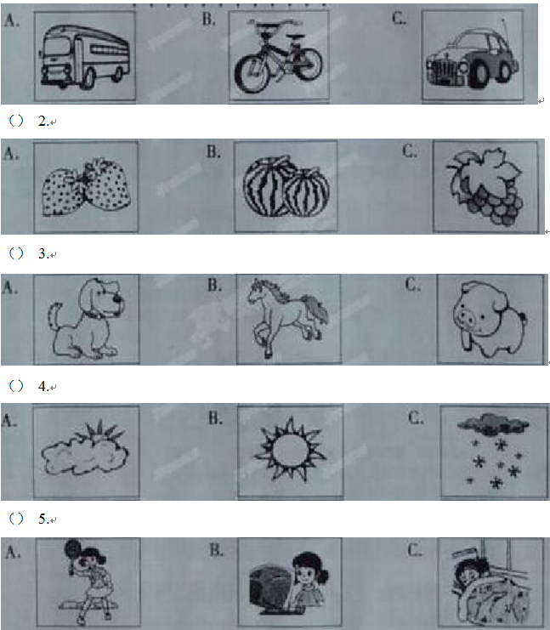

第二题 对话理解 这一大题共有5个小题，每小题你将听到一组对话和一个问题。请你从每小题所给的A、B、C三个选项中，选出一个最佳选项，并在答题卡上将该项涂黑。
( ) 6. A. Walking. B. Swimming. C. Dancing
( ) 7. A. Expensive. B. Beautiful. C. Cheap.
( ) 8. A. Strangers. B. Friends. C. Classmates.
( ) 9. A. At the museum B. On the bus. C. In the street.
( ) 10. A. She has cleaned them. B. She has thrown them away. C. She has put them under the bed.
第三题 语篇理解 这一大题你将听到一篇短文。请你根据短文内容和所提出的5个问题，从每小题所给的A、B、C三个选项中，选出一个最佳选项，并在答题卡上将该项涂黑。
( )11. When did Jim wake up yesterday morning?
A. At 7:45 B. At 8:00 C. At 8:15
( )12. Why did he run to school?
A. Because he liked running in the rain.
B. Because the school was far from his home.
C. Because there was something wrong with the bus.
( )13. What was Mr Smith doing when Jim came in ?
A. He was waiting for him.
B. He was giving his lesson.
C. He was doing experiments.
( )14. How did Mr Smith feel at first when he saw Jim?
A. He seemed pleased. B. He felt surprised. C. He was unhappy.
( )15. What can we know from the story ?
A. An interesting lesson can warm students.
B. You can get good grands if you like your teachers.
C. Students can become more interested in study if teachers love them.
II. 单项选择（每小题1分， 共15分）
请你从每小题所给的A、B、C三个选项中，选出可以填入空白处的最佳选项，并在答题卡上将该项涂黑。
( )16. Last month, we went to Li Zongsheng's concert. The beautiful songs about his younger day reminded us to love _________ .
A. yours B. theirs C. ours
( )17. —It's said that a college student had a _______ to Tibet with 500 yuan for a month.
—How surprising ! Once you have an idea to go somewhere, do it!
A. match B. travel C. change
( )18. During the World Cup, a large number of soccer fans fly to Brazil. It has _________ a great place for fans to have fun.
A. made B. kept C.become
( )19. —Have you watched A Bite of China recently?
— Of course. I do believe Chinese food is ______ in the world.
A. the most delicious B. more delicious C. delicious
( )20. —The song Where did the time go? tells us that our parents grow old without being noticed.
—We should stay with them as ________ as possible .
A. often B. soon C. little
( )21. —Mrs Li, will you be angry _______ your students don't obey the rules in class?
—A little. But I will stop them in a friendly way.
A.if B.unless C. though
( )22. —What are you busy doing these days, Mr Zhao?
— I ________ my newborn baby. You can't imagine how busy I am !
A. look after B. looked after C. am looking after
( )23. —Jack, I want to go to ________ to see a dentist. Could you tell me the address?
—No problem.
A. Room 606 B. No.2 Hospital C. Fifth Avenue

( )24. —The more I get to know Nancy, the more I can realize that we have a lot ________ .
—No wonder she is your best friend.
A. in style B. in common C. in need
( )25. —Mom I did best in our group discussion today.
—Well done! I __________ you.
A. am mad at B. am patient with C. am proud of
( )26. Many successful people have the same quality — they never __________ no matter what difficulties they've had.
A. give up B. stay up C. cheer up
( )27. —The ship sinking of Korea teaches us to care for ourselves and the people around us.
— So it is. ____________ , life is the most important to everyone.
A. For example B. At last C. After all
( )28. —___________ ?
—Sorry. There is no one named Gary. You must have the wrong number.
A. Can I help you B. What's the matter C. Is that Gary speaking
( )29. —It's time to graduate. Why not get our teachers some flowers to say thanks?
—____________ . They have done so much for us and we will miss them.
A. That's all right B. Good idea C. I hope not
( )30. —At present, many people like talking about "Kuaidi" and “Didi”. I really wonder____.
—You can order a taxi through them on your mobile phone easily.
A. how can I use them B. who uses them most C. what they are used for
III. 完形填空（每小题1分，共15分）
阅读下面短文，掌握其大意，然后从每小题所给的A、B、C三个选项中，选出可以填入空白处的最佳选项，并在答题卡上将该项涂黑。
Each of us fails from time to time . If we are wise, having enough experience and knowledge, we regard these failures(失败) as a necessary and 31 part of learning. But often as parents and teachers, we don't 32 this right(权利) to our children.
Donnie was a third grader in my class. His 33 about failure kept him from classroom games that other children enjoyed. He 34 answered my questions — he was afraid of making mistakes.
I tried my best to build his self-confidence. But nothing changed 35 midterm, when Mary, a new teacher, came. She was young and pretty, and she was loved by every student 36 Donnie. It was her who made a big difference to Donnie later.
One morning , they were doing math problems at the blackboard. Donnie had copied the problems clearly and 37 . But he'd missed the fourth problems and began to cry with his head in his arms.
I didn't know what to do. Suddenly, a smile 38 on Mary's face . From the desk she got a
box 39
pencil. "Look, Donnie," she said gently, kneeling(蹲在)beside him. "I've got something to 40 you." She remove the pencils, one at a time, and placed them on his desk.
"See these pencils, Donnie," she continued. " They 41 Mrs Landon and me. See how the erasers are worn(磨损)？That's because we make mistakes too. But we erase the mistakes and try again. That's what you 42 learn to do , too."
She kissed him and stood up, "Here," she said, I'll leave one of these pencils on 43 desk, so you'll remember that everybody makes mistakes, even teachers." Donnie looked up with 44 in his eyes and a smile.
The pencil became Donnie's prize. That , together with Mary's encouragement, gradually made him understand 45 the meaning of making mistakes is — it's all right to make mistakes, as long as you erase them and try again.
( )31. A. similar B. active C. important
( )32. A. offer B. pass C. send
( )33. A. puzzle B. worry C. complaint
( )34. A. always B. usually C. seldom
( )35. A. since B. after C. until
( )36. A. including B. except C. without
( )37. A. simply B. carefully C. casually
( )38. A. Appeared B. froze C. disappeared
( )39. A. made of B. covered by C. filled with
( )40. A. tell B. show C.ask
( )41. A.come to B. refer to C. belong to
( )42. A. might B. could C. must
( )43. A. your B. his C. her
( )44. A. hate B. love C. fear
( )45. A. how B. why C. what
IV. 阅读理解（一）（每小题2分，共30分）
阅读下列短文，从每小题所给的A、B、C三个选项中，选出可以填入空白处的最佳选项，并在答题卡上将该项涂黑。
（A）
Are you bored with your daily routine? Here are some things you should try before you are 18, because after that it's too late!
Learn to swim
Actually this is so important it could save your life. If you can't swim well, you won't be able to do water sports like water skiing , surfing and diving. Even taking a boat trip will safe for you. Make sure you do it.
Collect something
One of the best hobbies for under-18s is collecting things. You could collect Chinese stamps, or you could collect things that make you remember what you've done, like cinema tickets for films. The best way to collect is to have a special album to put your collection in and to write what each thing means to you.That way you won't forget.
Try at least one kind of team sport
Being a good team player is an important skill in life. You can't just think of yourself, but have to work with other people. Other advantages of team sports like basketball, foot- ball and baseball are that they keep you fit and healthy, and they are also great fun. Teams usually have a good social life too — you'll go to lots of parties and make many friends.
Write your family tree
When you are young, get to know all the older people in your family and find out as much as you can about when they were young. Draw a family tree and make notes about each person so that you won't forget.
( )46. According to the passage, we should learn to swim because it could _____________.
A. save our lives B. keep us fit and healthy C. make us work well with others
( )47. The best way to collect thing is __________.
A. to have a special album B. to buy more stamps and tickets
C. to exchange them with your friends
( )48. Being a good team player can help you ________.
A. think of yourself B. have a good social skill C. become a ball game star
( )49. In order not to forget the order people in your family, you should __________.
A. go to lots of family parties
B. find something that they used
C. draw a family tree and make notes
( )50. The passage mainly tells us that ________.
A. hobbies play an important role in everyone's growth
B. you are supposed to try some things before you're 18
C. everyone should get into good habits when they are young
(B)
In 2002, I wrote a letter for my future self with instructions not to open until my birthday in 2014. It is 2014 now. Yesterday was my birthday and I opened it. This is what it said:
Dear Sherri,
By the time you read this, you will be30. At the age of 18 I had many dreams about you. Right now I hope you have traveled and seen everything you've always wanted to. both in Canada and abroad, maybe you have even settle down somewhere in France, and maybe you are working in the field of art. I hope you're married to Gwynn — the man of your dreams. You'll probably have two children — a girl and a boy.
If everything goes okay, you'll be living in France in a big house in a small town with Gwynn and your two children. You are doing research in painting. Gwynn will be a computer programmer and you will be doing all right for yourselves.
However, if things don't go according to plan, I wish you love , happiness and joy.
Love
Sherri “18”
When I read this, I was surprised. So much of what I wanted has come true.
I did travel to a few more places in Canada. I've traveled to the UK, Australia and Egypt. I have been living in France for nearly 4 years in a big house, in a small suburb(郊区), in a major city. I am an art teacher in a university. I have two lovely kids.
But not everything went as what I hoped. I married a man named Tom Rees, and he is an excellent artist. We are doing all right for ourselves.
I find it cool how the dreams of a young girl can become a grown woman's reality(现实).
( )51. How long did Sherri wait to open the letter?
A. For 12 years. B. For 18 years. C. For 30 years.
( )52. What does the underlined phrase"settled down" mean in Chinese?
A.参观 B.旅行 C.定居
( )53. Among her dreams, which one did NOT come true?
A.To work in the field of art.
B. To be a mother of two kids.
C. To marry a computer programmer.
( )54. What can we infer(推断) from the passage?
A. She plans to move to the UK later.
B. She enjoys the life with her family now.
C. She loses hope because not everything goes well.
( )55. What is the best title for this passage?
A. Dream on the Way B. Dream and Reality C. How to Achieve Your Dream
（C）
What does it mean to be green? "Green" is more than just a color. It also means taking special steps to protect the environment — the water, the land, and the air we breathe. Why green? Plants are green, and without them the earth wouldn't be such a lovely home for us human beings.
Sometimes people call ours a "throwaway society". That means we are always throwing away old things and buying new ones. Many times, if you no longer need something, someone else just might need it. For example , if your brother is old enough not to play with his plastic bike, why not give it to another family who has a little kid so that they don't need to buy one? And one less large plastic toy doesn't need to be produced.
Recycling(回收利用) has never been easier. Many organization will pick it up right in front of your house and some towns even require(要求) it. Tell your mom or dad you want to become"Chief of Make sure you encourage everyone in your house to think whether things can be reused or recycled before they're thrown away.
Almost everyone likes traveling. But next time before you travel around the world, take a look at your own backyard. Is there a place where you could plant a tree or put in a little fruit or vegetable garden? If so, get there and get your hands dirty. Then you can watch with pride as your tree takes root, and your garden plants grow into big plants full of ripe, red tomatoes of tiny, juicy blueberries. Who knew being green would taste so good?
( )56. In the first paragraph, the writer introduces the topic of the passage by __________ .
A. telling an interesting story
B. explaining the word "green"
C. giving some special examples
( )57. In a "throwaway"society, _________ .
A. people shouldn't produce any plastic things
B. people can get anything they want from others
C. people always throw away the used things and buy new ones
( )58. To be "Chief of Recycling", you should ________.
A. recycle things all by yourself
B. ask your family to use the old things all the time
C. find a place to keep the things that can be recycled
( )59. You are advised to run a fruit or vegetable garden in order to __________.
A. create a green environment
B. make a lot of money
C. get your hands dirty
( )60. The purpose of the passage is to tell us that __________.
A. we must enjoy the nature
B. we had better eat more green food
C. we should protect our environment
第II卷（共45分）
V. 听力填空（每小题1分，共5分）
这一大题你将听到一篇短文。请你根据所听内容，完成下面的表格，并将获取的信息填到答题卡相应的位置上。每空一词。
A New Learning Program— B.Y.O.T |  | 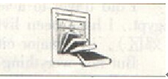
Aim | Student can get free 61._____ in their free time.
Opinions | The learning must be 62._____ than ever because of the program.  However, some school think that the students may 63.____ their iPads.
Result | It is around 64.____ years since a new learning way was used and B.Y.O.T will greatly improve it.  More schools 65.____ some in the rural(农村) areas are coming along !

VI. 补全对话（每小题1分，共5分）
根据对话内容，从方框内所给的选项中选出最佳选项，并在答题卡上将该项涂黑。选项中有两项为多余项。
（Kitty and Mark meet outside the school gate after school.）
A: Hi, Mark. Ben's birthday is coming. I'm planning a surprise party for him this Saturday. 66
B: Sure, Kitty. I'm free. What are we going to do at the party?
A: 67 We'll also have a barbecue. Someone will bring Ben to the party without telling him.
B: Really? You mean he doesn't know the party at all ?
A: 68 We've also prepared some gifts for him.
B: Sounds great. I'm looking forward to it. 69
A: It's in my house. You can come earlier. See you then.
B: OK. 70
66.________ 67.________ 68.________ 69.________ 70._________
VII. 阅读理解（二）（每小题2分，共10分）
阅读下面图文，简要回答所给问题，并将答案写在答题卡相应的位置上。
World Book Day falls on April 23 every year. It was set up by the UNESCO(联合国教科文组织)in 1955 to encourage people to discover the pleasure of reading. It means your teachers or parents tell you to do so."Reading for pleasure" plays a more important role in one's growth than one's family background.
Books, magazines, newspapers and other kinds of materials can help us know more about the outside world and perfect us. However, computer games, online videos and Internet are pushing books off the shelf. Some experts believe it's a worrying trend(趋势). Each Chinese read 0.38 more books in 2013 than2012 but still far fewer than those in major developed countries. Even worse, many bookstores have closed their doors because many book lovers starts to buy fewer books than before.
However, many people do still prefer reading because it has been part of their life. It can benefit(使受益) people in many ways. It gives us information about other countries and places of the world. It also has a strong influence on forming our personality and makes us more intelligent. The more we read,the more we know. The more we know, the smarter we become. It's never too late to start reading. So jump into the wonderful world of books now !
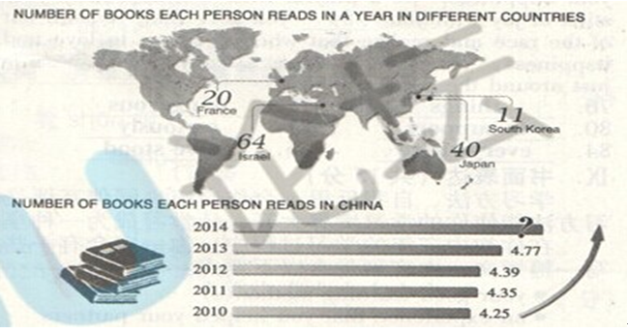

71. In which of the countries does each person read more than 15 books in a year?
__________________________________________________________________________
72. Why did people set up World Book Day?
__________________________________________________________________________
73. What are the experts worrying about?
__________________________________________________________________________
74. Is it right that each Chinese read 0.38 more books in 2012 than 2011? If not, what's the result?
__________________________________________________________________________
75. How many books did you read in 2013 ? What do you think of reading?
__________________________________________________________________________
VIII.词语运用（每小题1分，共10分）
根据语篇内容，用方框中所给词的正确形式填空，使短文通顺、连贯，并将答案写在答题卡相应的位置上。方框中有
两个词为多余项。
I that thing stand anger serious who find near support danger everywhere
For a long time, I saw happiness as a huge banner across the finish line of a long race. I felt that only when I completed certain 76 could I finally be happy in my life. Most of the time I felt like a tortoise. I believe that being slow and strong-minded would win the race. At other times I would act like a rabbit. I tried different roads at a 77 speed, hoping to reach that banner a little faster. Gradually, I began to see that no matter how long I raced towards it, the banner never got any 78 . I finally decided one day to sit down and take a rest. It was then that I saw my happiness sitting beside79 .
It had been with me as I worked hard 80 my family, as I played with my children and I heard their laughter and even when I was 81 ill with my wife at my side looking after me. It had been with me as I raced towards that stupid banner. I just didn't have the ability to see it.
There is an old saying 82 goes,"Tension is who you think we should be. Relaxation is who you are."Perhaps we all should stop our race towards the perfect life we think we should have. We should enjoy the life we have now. Happiness will never 83 under some banner far away. You will find it in your own heart, soul and mind. You will find it when you realize that others love you just as you do.
Don't be a tortoise or a rabbit when it comes to your happiness. Be a playful little dog and carry your stick of joy with you 84 you go. Take yourself out of the race and realize that when it comes to love and happiness, you 85 there already. Happiness is just around the corner.
76. _________ 77. _________ 78. _________ 79. _________ 80. _________
81. _________ 82._________ 83. _________ 84. _________ 85. _________
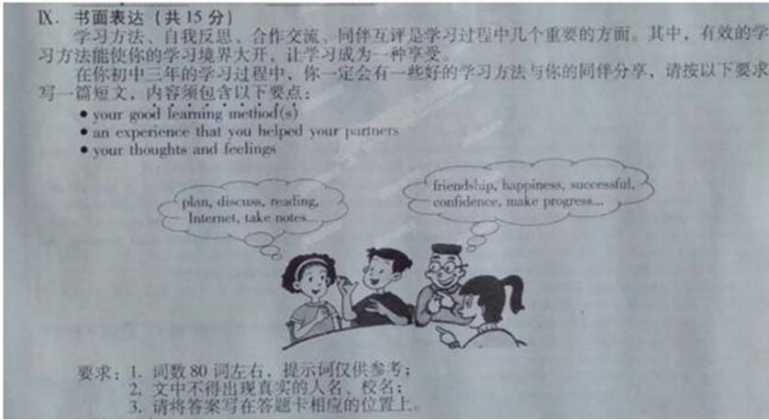

山西省2014年普通高中招生考试试卷

英语参考答案

I. 1-5 CABBC 6-10 CBABB 11-15 ACBCC
II. 16-20 CBCAA 21-25 ACBBC 26-30 ACCBC
III. 31-35 CABCC 36-40 ABACB 41-45 CCABC
IV. 46-50 AABCB 51-55 ACCBB 56-60 BCCAC
V. 61. education 62. better 63. break 64. 13/thirteen 65. especially
VI. 66.C 67. G 68. B 69. D 70. A
VII.
71. France，Japan and Israel.
72. Because they wanted to encourage people to discover the pleasure of reading./They wanted to
encourage people to discover the pleasure of reading.
73. They are worrying(that)computer games, online videos and Internet are pushing books off the shelf. / Computer games, online videos and Internet are pushing books off the shelf.
74. No, it isn't. It's 0.04. / No. It's 0.04.
75. I read one (book) / two(books) / ... / One. / Two. / Three. /...
Reading / It gives us information about other cultures and places of the world. / Reading / It has a strong influence on forming our personality and makes us more intelligent. / ...
VIII. 76. things 77. dangerous 78. nearer 79. me 80. to support
81. seriously 82. that 83. be found 84. everywhere 85. have stood
A possible version:
Good learners must have good ways. Discussing in a group really helps me have a better understanding of what I’ve learned. It broadens our mind and allows us more chances to express our thoughts.
Shy and nervous, my classmate Jeff used to hide himself behind books. Answering questions in public was quite a difficult job for him. Once our math teacher asked us to solve a difficult problem. I encouraged Jeff to discuss his idea with us and we found his way was so creative . Then we advised him to write his answer on the blackboard and explain it to us .Believe it or not, he did it and we saw his great improvement after that.
Discussing in a group not only makes me enjoy the happiness of being a good learner but also deepens the friendship between Jeff and me. Knowledge comes from communicating and questioning. By discussing, we learn more wisely and better.

